The Trebuchet:
Physics, numerics, and connections to millennia of human activity.

Physics Honors Thesis
Matthew Covington

Introduction 3

I. Semi-Analytic Models 5

II. Lagrangian Mechanics 11

III. Riemann Equations and Numerical Simulation 15

IV. Optimization 17

V. N-armed Trebuchets 26

VI. Conclusion 33

Introduction
The Chinese invented the trebuchet, a super catapult, around 400 BC, and it was introduced into Western Civilization around the tenth century. The trebuchet could hurl large projectiles hundreds of feet and into or over the walls of castles. The device was abandoned once improved metallurgy allowed the cannon to outperform the trebuchet. Despite the importance that the trebuchet played in medieval battles, the device was all but forgotten until recently, when several attempts were made by engineers, medievalists, and college students to recreate trebuchets and optimize their performance. Surprisingly, the physics literature has said very little about this ingenious device. Standard mechanics texts contain no treatment of it.
One might then ask why studying the mechanics of an ancient war machine is in any way important or productive. First of all, the motion of the trebuchet largely parallels that of the swinging or throwing motions of the arm. Its mechanics is similar to the swing of a scythe, axe, sledgehammer or pick, and to the throw of a baseball. Indeed, trebuchet motion has for ages been key to human development. Also, in modern society, this motion is seen in most sports: the forehand throw of a Frisbee, the swing of a tennis racket, baseball bat, or golf club; even the excitatory motion that zips a water skier across the wake. Finally, the motion of an n-armed trebuchet is analogous to super-elastic-bounce, a motion found in models of super-novae. Given all this it is surprising that physics has been so silent about such a universally important motion. Analysis of the trebuchet can provide insight into the mechanics of many other systems, particularly in biomechanics. This motion is essential to everyday work and play, and physics so far has said very little about it.
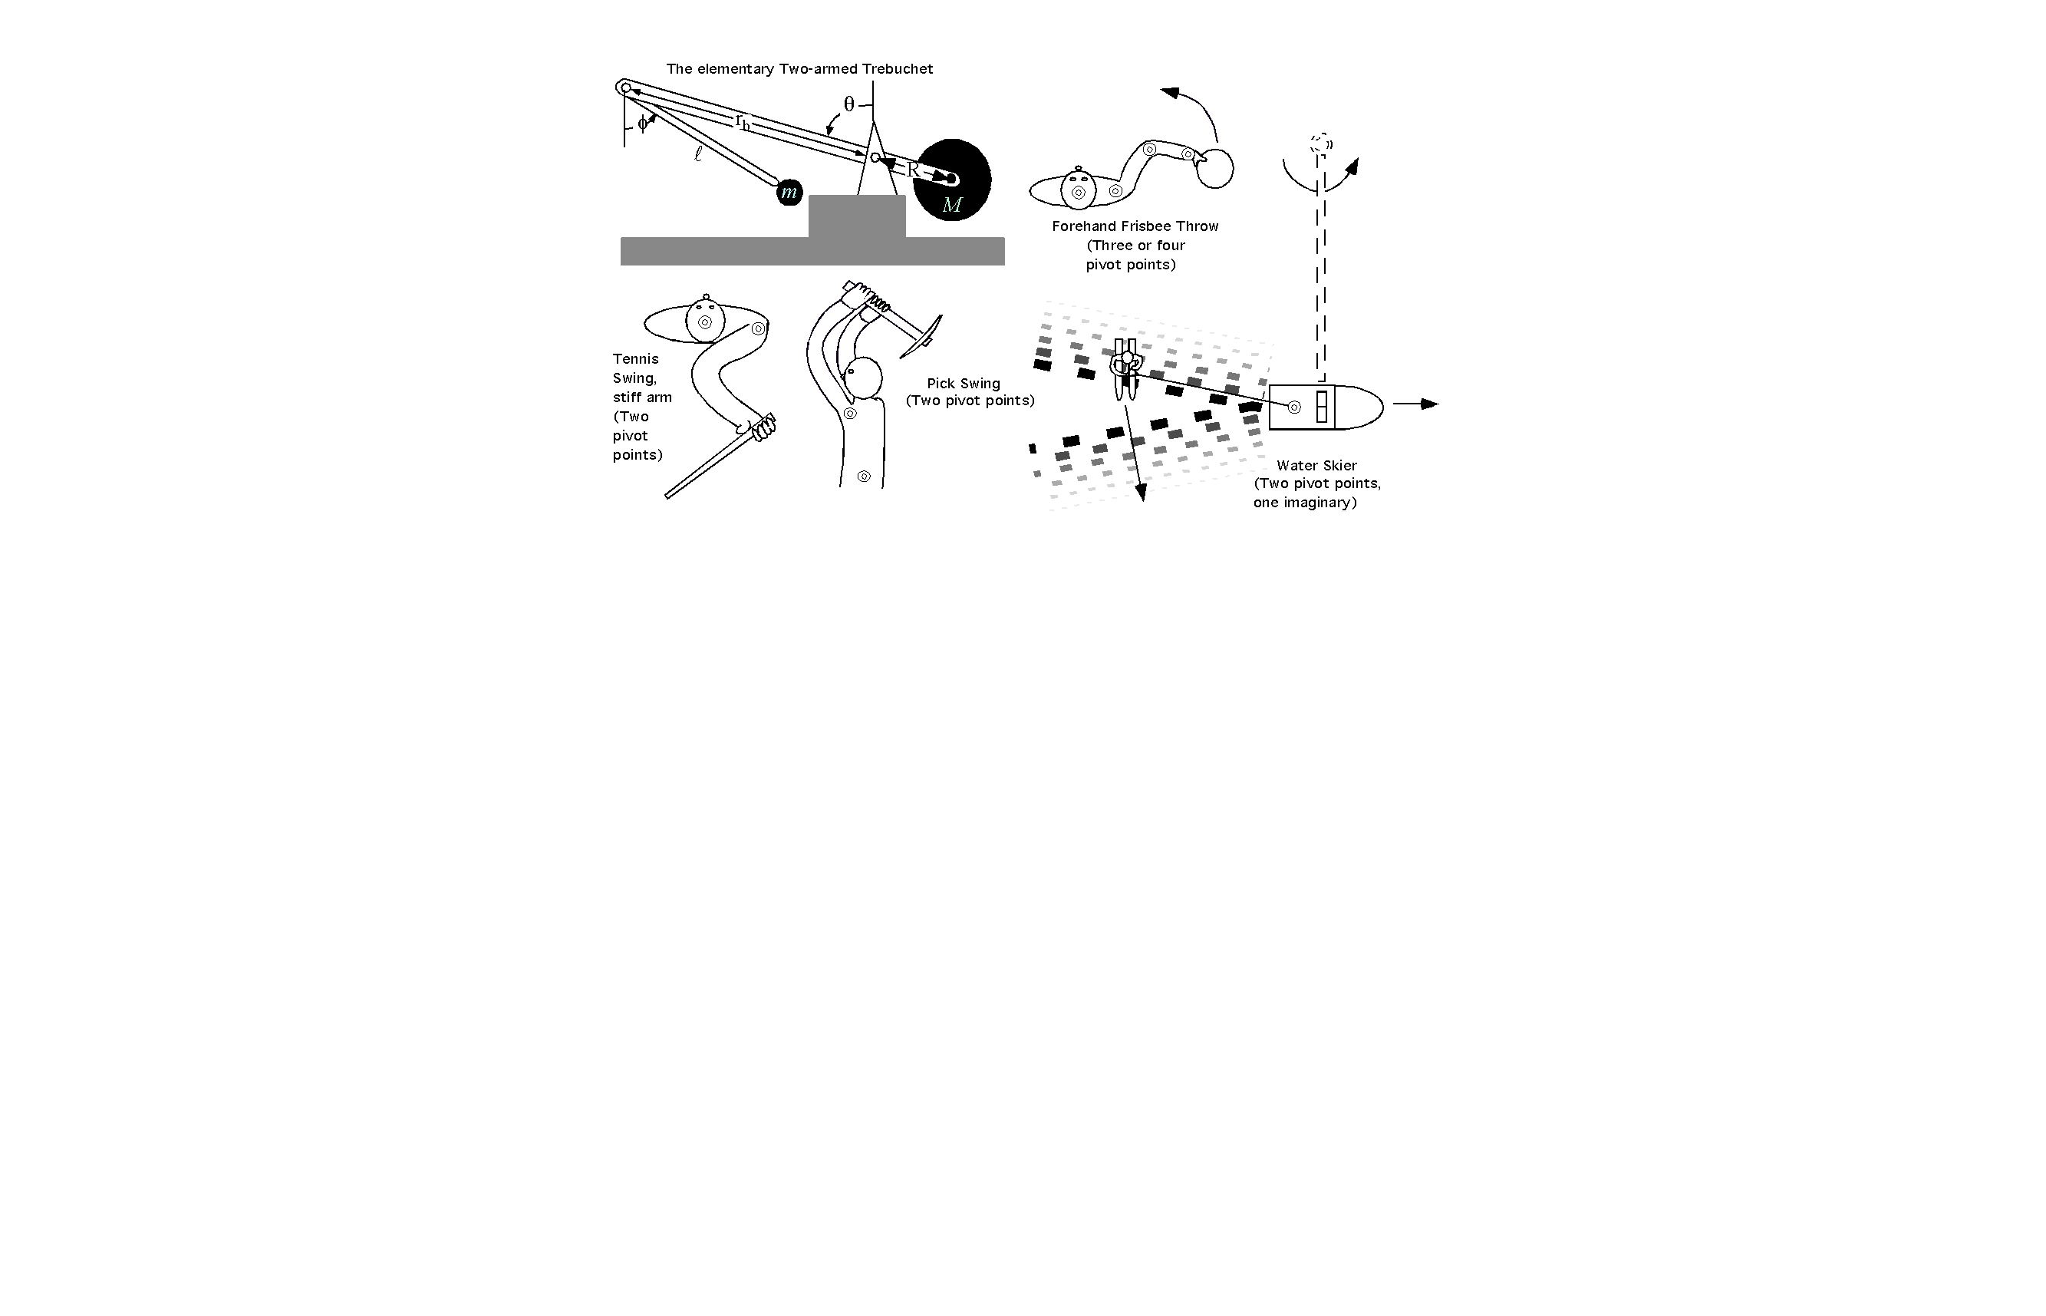
Figure 1: The trebuchet and analogous motions
The trebuchet has a large mass on one end of a lever that is fixed on a fulcrum. On the other end of the lever is a second arm (often a rope) onto which the projectile is attached. The second arm hangs down from the main arm like a pendulum. During launch, the lever pivots as the large mass is pulled down by gravity, and energy transfers rapidly to the projectile. The device is something like a catapult; however, most catapults are spring driven devices with only one arm, whereas the trebuchet is a counter-weight device with two arms and is much more effective than a simple catapult.

I. Semi-Analytic Models
Though seemingly primitive, the motion of the trebuchet is extremely complex. The system of differential equations that governs its motion is highly non-linear. Consequently, the trebuchet does not lend itself to straightforward analytic modeling. However, our understanding of the motion can be furthered if we can create semi-analytic models that closely imitate actual trebuchet motion. There are two main types of acceleration that the projectile experiences during a trebuchet throw: acceleration due to centrifugal force, and acceleration due to parametric resonance. Examining these sources of acceleration allows us to understand more clearly what occurs during a throw.
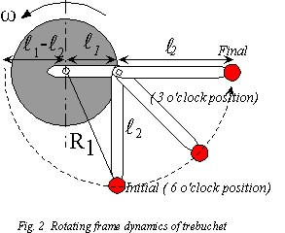

We can roughly approximate the influence of centrifugal acceleration by assuming that the main trebuchet arm is moving with constant velocity. The centrifugal acceleration of a mass at a given radius r in a rotating frame is ω²r in the outward radial direction. Therefore, the centrifugal force on a projectile with mass m is:
$F^{\text{centrifugal}}={mω}^{2}r$ (1)
We can then calculate the effective potential for the rotating frame:
$F=−\frac{\text{dV}}{\text{dr}} ⇒ V^{\text{centrifugal}}(r)=−\frac{1}{2}{mω}^{2}r^{2}$ (2)
The final beam relative speed of the projectile can be calculated by equating the difference in potentials (between r_{initial} and r_{final}) to the final kinetic energy of the projectile.
$\begin{aligned}{\text{KE}}_{\text{beam}\text{ rel}}=\frac{1}{2}{\text{mv}}^{2_{\text{beam}\text{ rel}}}=V(r_{o})−V(r_{f})=\frac{1}{2}{mω}^{2}r_{f^{2}}−\frac{1}{2}{mω}^{2}r_{0^{2}} \\ \\ v_{\text{beam}\text{ rel}}=ω\sqrt{(r_{f^{2}}−r_{o^{2}})}\end{aligned}$ (3)
For a half-cocked (6 o’clock) initial starting position r₀ =l₁ – l₂, for a fully-cocked (9 o’clock) starting position r₀² = l₁²+ l₂². In either case, r_{f} = l₁ + l₂. Thus, the final beam relative velocity can be expressed:
$v_{\text{beam}\text{ rel}}=\left\{\begin{matrix}ω\sqrt{2l_{1}l_{2}}\text{ for half- cocked} \\ 2ω\sqrt{l_{1}l_{2}}\text{ for fully-cocked}\end{matrix}\right.$ (4)
The portion of the projectile velocity due to centrifugal force is greater for the fully-cocked trebuchet. This makes sense because, for the fully-cocked trebuchet, the projectile has traveled further through the effective potential. To express the final lab relative velocity we need only add the tangential angular velocity of the main beam (which is in the same direction of the beam relative velocity). The main beam velocity is simply ω(l₁ + l₂). Therefore the final lab relative velocity for the projectile is:
$v_{\text{lab}\text{rel}}=\left\{\begin{matrix}ω(l_{1}+l_{2}+\sqrt{2l_{1}l_{2}})\text{ for half-cocked} \\ ω(l_{1}+l_{2}+2\sqrt{l_{1}l_{2}})\text{ for fully-cocked}\end{matrix}\right.$ (5)
If we assume arm lengths l₁=5 and l₂=4 then we can calculate approximate final velocities.
$v_{\text{lab}\text{rel}}=\left\{\begin{matrix}\text{15}\text{.}\text{32}ω\text{ half-cocked} \\ \text{17}\text{.}\text{94}ω\text{ fully-cocked}\end{matrix}\right.$ (6)
Notice that these velocities are significantly greater than the velocity of a fixed arm of length l₁+l₂ rotating at the same angular velocity ω. (This velocity would only be 9ω). The significant difference in velocity is entirely due to the centrifugal acceleration allowed by the trebuchet, and it shows us that the trebuchet derives much of its accelerative ability from this centrifugal force.
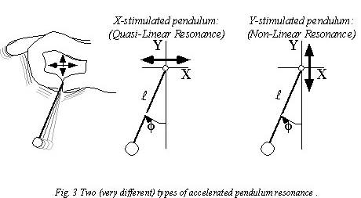 While centrifugal force is important, a second source of acceleration also plays a role in trebuchet motion. The acceleration of the main arm creates a parametric resonance for the second arm. There is a universal human motion often referred to as “twiddling” – whirling one’s glasses, jiggling one’s keys, or swinging other objects in such a manner as to relieve boredom or nervousness. This motion, though seemingly unrelated, has analogues in both classical and modern physics – including that of the trebuchet. Imagine holding a string with a mass attached to the end of it.

There are primarily two ways that one can move the string to excite motion in the mass (see Figure 3): wiggle the string back and forth, or wiggle the string up and down. A regular back-and-forth motion will gradually excite harmonic motion that grows, at best, linearly with time. However, a correctly applied up-and-down motion can excite the pendulum so that the amplitude of its oscillation grows quasi-exponentially. This is parametric resonance. One should note that this up-and-down resonance is not self-starting. The pendulum must be cocked slightly to the side. This is also true for optimized trebuchet motion – acceleration during a standard trebuchet throw is improved by having the second arm initially cocked off to the side.
The equation of motion for this non-linear resonance can easily be derived using the equivalence principle. According to this principle, the effective gravity (g_{eff}) experienced by the pendulum can be expressed by subtracting the acceleration due to the oscillation (a) from the acceleration due to gravity (g).
$g_{\text{eff}}=g−a(t)=\left(\begin{matrix}0 \\ −g\end{matrix}\right)−\left(\begin{matrix}a_{x}(t) \\ a_{y}(t)\end{matrix}\right)$ (7)
For examining non-linear resonance, we are only interested in the y component of the acceleration. Suppose that the person holding the string oscillates his hand up and down according to $Y(t)=A_{y}\text{cos}(ω_{y}t+α_{y})$ with amplitude A_{y}, angular velocity ω_{y}, and phase α_{y}. This acceleration would correspond to a first trebuchet arm moving with constant angular velocity. It follows that $g_{y}^{\text{eff}}(t)=−g−\overset{¨}{Y}=−g+ω_{y^{2}}A_{y}\text{cos}(ω_{y}t+α_{y})$. The general equation of motion for such an oscillating pendulum is:
$\frac{d^{2}φ}{{\text{dt}}^{2}}−\frac{g_{y}^{\text{eff}}}{l}\text{sin}φ=0$, reduced to $\frac{d^{2}φ}{{\text{dt}}^{2}}−\frac{g_{y}^{\text{eff}}}{l}φ=0$ for small angles (sin φ ~φ). (8)
We then substitute in for the effective gravity, and set α_{y} = π so that Y(t) accelerates upward at t=0.
$\frac{d^{2}φ}{{\text{dt}}^{2}}+\left(\frac{g}{l}+\frac{ω_{y^{2}}A_{y}}{l}\text{cos}(ω_{y}t)\right)φ=0$ (9)
This equation takes a form of the Schrödinger wave equation known as a Mathieu equation.
$\frac{d^{2}φ}{{\text{dx}}^{2}}+(E−V(x))φ=0$, where: $V(x)=−V_{0}\text{cos}(\text{nx})$ (10)
For the pendulum, time (t) takes the place of position (x) for the Schrödinger equation, and the spatial potential V(x) is replaced by an effective gravity potential ~cos(ω_{y}t). The acceleration of φ can be expressed:
$\overset{¨}{φ}=−φ(t)\left(\frac{g}{l}+\frac{ω_{y^{2}}A_{y}}{l}\text{cos}(ω_{y}t)\right)$ (11)
Then, if we neglect gravity we can approximate the magnitude of the initial φ acceleration as:
$\overset{¨}{φ}\text{\sim }−φ(0)\frac{ω_{y^{2}}A_{y}}{l}$. (12)
This provides us further insight into the accelerative capacity of the trebuchet. The acceleration at t=0 is proportional to the square of the main arm angular velocity, and to the angle at which the second arm is cocked. This model of vertical acceleration breaks down as the trebuchet “unfolds.” Accordingly, the amplified acceleration due to non-linear resonance can only be maintained in the early stages of a trebuchet throw.
By examining these two accelerative forces it becomes plain that most of trebuchet acceleration occurs early in the throw. Only the tangential component of the centrifugal force is useful for accelerating projectile, and it varies with φ ($F_{\text{tan}\text{gential}}^{\text{centrifual}}\text{\sim }F^{\text{centrifugal}}\text{cos}φ$). Therefore, it is greatest at φ=0, and zero at φ= -90 or 90. If the second arm passes the φ=90 point then the centrifugal force acts to slow the projectile. The parametric resonance adds to the velocity as long as φ < 0. Once the angle of second arm becomes positive, the acceleration due to parametric resonance becomes negative and therefore is a braking force (this is seen in equation 12). So, while φ < 0 the centrifugal force and parametric resonance act together to increase the velocity of the projectile. However, as the second arm approaches the fully extended position, the centrifugal force and parametric resonance act against each other, and the centrifugal forces dwindles to zero.

II. Lagrangian Mechanics
The first step toward expressing the trebuchet analytically is to pick a system of generalized coordinates. These are coordinates that specify an exact position of the system. I will use the angles θ and φ to represent the angles of the first and second arms, respectively. Angles increase in the counterclockwise direction.

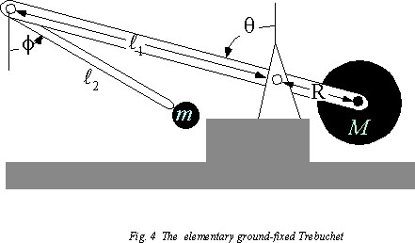

Next we must determine the relationship between θ and φ and the Cartesian coordinates for the positions of all of the masses in the system. To simplify the equations of motion I assume that the arms of the trebuchet are massless; thus, we must simply specify the location of the large counterweight (M) and the projectile (m).
Coordinates of M: Coordinates of m: (13)
X = R sin θ x = -l₁ sin θ + l₂ sin φ
Y = -R cos θ y = l₁ cos θ - l₂ cos φ

Next we can derive the kinetic energy (T) of the system – in terms of the generalized coordinates. To do this, we first take the time derivatives of the coordinates of each of the masses.
$\begin{aligned}\overset{˙}{X}=R\overset{˙}{θ}\text{cos}θ \\ \overset{˙}{Y}=R\overset{˙}{θ}\text{sin}θ\end{aligned}$ $\begin{aligned}\overset{˙}{x}=−l_{1}\overset{˙}{θ}\text{cos}θ+l_{2}\overset{˙}{φ}\text{cos}φ \\ \overset{˙}{y}=−l_{1}\overset{˙}{θ}\text{sin}θ+l_{2}\overset{˙}{φ}\text{sin}φ\end{aligned}$ (14)
Kinetic energy is expressed as $T=\frac{1}{2}{mv}^{2}$. To express the kinetic energy of each mass we need only note that for Cartesian coordinates, $v^{2}={\overset{˙}{x}}^{2}+{\overset{˙}{y}}^{2}$.
$T_{M}=\frac{1}{2}M({\overset{˙}{X}}^{2}+{\overset{˙}{Y}}^{2})=\frac{1}{2}M(R^{2}{\overset{˙}{θ}}^{2}{\text{cos}}^{2}θ+R^{2}{\overset{˙}{θ}}^{2}{\text{sin}}^{2}θ)=\left[\frac{1}{2}{\text{MR}}^{2}{\overset{˙}{θ}}^{2}\right]$ (15)

$\begin{aligned}T_{m}=\frac{1}{2}m({\overset{˙}{x}}^{2}+{\overset{˙}{y}}^{2})=\frac{1}{2}m(l_{1^{2}}{\overset{˙}{θ}}^{2}{\text{cos}}^{2}θ+l_{2^{2}}{\overset{˙}{φ}}^{2}{\text{cos}}^{2}φ−2l_{1}l_{2}\overset{˙}{θ}\overset{˙}{φ}\text{cos}θ\text{cos}φ \\ +l_{1^{2}}{\overset{˙}{θ}}^{2}{\text{sin}}^{2}θ+l_{2^{2}}{\overset{˙}{φ}}^{2}{\text{sin}}^{2}φ−2l_{1}l_{2}\overset{˙}{θ}\overset{˙}{φ}\text{sin}θ\text{sin}φ) \\ \\ \text{So, }T_{m}=\left[\frac{1}{2}m(l_{1^{2}}{\overset{˙}{θ}}^{2}+l_{2^{2}}{\overset{˙}{φ}}^{2}−2l_{1}l_{2}\overset{˙}{θ}\overset{˙}{φ}\text{cos}(θ−φ))\right]\end{aligned}$ (16)
The total kinetic energy of the system is T = T_{M} + T_{m} and can be expressed in a quadratic form.
$\begin{aligned}T=\frac{1}{2}({\text{MR}}^{2}+{\text{ml}}_{1^{2}}){\overset{˙}{θ}}^{2}−\frac{1}{2}{\text{ml}}_{1}l_{2}\overset{˙}{θ}\overset{˙}{φ}\text{cos}(θ−φ) \\ −\frac{1}{2}{\text{ml}}_{1}l_{2}\overset{˙}{φ}\overset{˙}{θ}\text{cos}(θ−φ)+\frac{1}{2}{\text{ml}}_{2}{\overset{˙}{φ}}^{2}\end{aligned}$ (17)
It is then useful to express this in terms of a dynamic metric coefficient (DMC) matrix:
$\begin{aligned}T=\frac{1}{2}\left(\begin{matrix}\overset{˙}{θ} & \overset{˙}{φ}\end{matrix}\right)\left(\begin{matrix}γ_{θ,θ} & γ_{θ,φ} \\ γ_{φ,θ} & γ_{φ,φ}\end{matrix}\right)\left(\begin{matrix}\overset{˙}{θ} \\ \overset{˙}{φ}\end{matrix}\right) \\ \\ \text{where }\left(\begin{matrix}γ_{θ,θ} & γ_{θ,φ} \\ γ_{φ,θ} & γ_{φ,φ}\end{matrix}\right)=\left(\begin{matrix}{\text{MR}}^{2}+{\text{ml}}_{1^{2}} & −{\text{ml}}_{1}l_{2}\text{cos}(θ−φ) \\ −{\text{ml}}_{1}l_{2}\text{cos}(θ−φ) & {\text{ml}}_{2^{2}}\end{matrix}\right)\end{aligned}$ (18)
We must also derive the potential energy of the system. The potential energy is due solely to gravity, so the only important coordinates are the y-coordinates of both masses. The total potential energy of the system can be expressed:
$V=\text{MgY}+\text{mgy}=−\text{MgR}\text{cos}θ+\text{mg}(l_{1}\text{cos}θ−l_{2}\text{cos}φ)$ (19)
According to the Lagrangian formalism of Newtonian mechanics, the total Lagrangian L = T – V obeys the following differential equation for any generalized coordinate μ:
${\overset{˙}{p}}_{μ}=\frac{d}{\text{dt}}\left(\frac{∂L}{∂\overset{˙}{μ}}\right)=\frac{∂L}{∂μ}$ (20)
Here, $p_{μ}=\frac{∂L}{∂\overset{˙}{μ}}$is the conjugate momentum for the generalized coordinate μ . For the trebuchet, we have two generalized coordinates, and therefore two conjugate momenta and two equations of motion. The conjugate momenta, p_{μ} , are also related to the DMC in the following way: $p_{μ}=\sum{γ_{μ,ν}\overset{˙}{ν}}\text{, or, for the trebuchet, }\left(\begin{matrix}p_{θ} \\ p_{φ}\end{matrix}\right)=\left(\begin{matrix}{\text{MR}}^{2}+{\text{ml}}_{1^{2}} & −{\text{ml}}_{1}l_{2}\text{cos}(θ−φ) \\ −{\text{ml}}_{1}l_{2}\text{cos}(θ−φ) & {\text{ml}}_{2^{2}}\end{matrix}\right)\left(\begin{matrix}\overset{˙}{θ} \\ \overset{˙}{φ}\end{matrix}\right)$(21)
This relation between conjugate momenta and the DMC is a general result for all generalized coordinate systems.
We get the left hand side of the Lagrange equations by differentiating the conjugate momenta with respect to time.
$\begin{aligned}{\overset{˙}{p}}_{θ}=\frac{d}{\text{dt}}[({\text{MR}}^{2}+{\text{ml}}_{1^{2}})\overset{˙}{θ}−{\text{ml}}_{1}l_{2}\overset{˙}{φ}\text{cos}(θ−φ)] \\ =({\text{MR}}^{2}+{\text{ml}}_{1^{2}})\overset{¨}{θ}−{\text{ml}}_{1}l_{2}\overset{¨}{φ}\text{cos}(θ−φ)+{\text{ml}}_{1}l_{2}\overset{˙}{θ}\overset{˙}{φ}\text{sin}(θ−φ)−{\text{ml}}_{1}l_{2}{\overset{˙}{φ}}^{2}\text{sin}(θ−φ) \\ \\ {\overset{˙}{p}}_{φ}=\frac{d}{\text{dt}}[({\text{ml}}_{2^{2}}\overset{˙}{φ}−{\text{ml}}_{1}l_{2}\overset{˙}{θ}\text{cos}(θ−φ)] \\ ={\text{ml}}_{2^{2}}\overset{¨}{φ}−{\text{ml}}_{1}l_{2}\overset{¨}{θ}\text{cos}(θ−φ)+{\text{ml}}_{1}l_{2}{\overset{˙}{θ}}^{2}\text{sin}(θ−φ)−{\text{ml}}_{1}l_{2}\overset{˙}{θ}\overset{˙}{φ}\text{sin}(θ−φ)\end{aligned}$(22)
The right hand sides of the equations are simply:
$\begin{aligned}\frac{∂L}{∂θ}=\frac{∂}{∂θ}\left(T−V\right)={\text{ml}}_{1}l_{2}\overset{˙}{θ}\overset{˙}{φ}\text{sin}(θ−φ)+{\text{mgl}}_{1}\text{sin}θ−\text{MgR}\text{sin}θ, \\ \text{and }\frac{∂L}{∂φ}=\frac{∂}{∂φ}(T−V)=−{\text{ml}}_{1}l_{2}\overset{˙}{θ}\overset{˙}{φ}\text{sin}(θ−φ)−{\text{mgl}}_{2}\text{sin}φ\text{.}\end{aligned}$ (23)
We then set ${{\overset{˙}{p}}_{θ}=\frac{∂L}{∂θ}\text{ and \{}\overset{˙}{p}}_{φ}=\frac{∂L}{∂φ}\text{.}$
$\begin{aligned}({\text{MR}}^{2}+{\text{ml}}_{1^{2}})\overset{¨}{θ}−{\text{ml}}_{1}l_{2}\overset{¨}{φ}\text{cos}(θ−φ)−{\text{ml}}_{1}l_{2}{\overset{˙}{φ}}^{2}\text{sin}(θ−φ)={\text{mgl}}_{1}\text{sin}θ−\text{MgR}\text{sin}θ \\ \\ {\text{ml}}_{2^{2}}\overset{¨}{φ}−{\text{ml}}_{1}l_{2}\overset{¨}{θ}\text{cos}(θ−φ)+{\text{ml}}_{1}l_{2}{\overset{˙}{θ}}^{2}\text{sin}(θ−φ)=−{\text{mgl}}_{2}\text{sin}φ\end{aligned}$ (24)
(24) is the set of non-linear differential equations that describe trebuchet motion. However, these equations by themselves are of little use to us. Due to their non-linearity, they do not lend themselves to analytic solution. Any further attempt to solve for the motion of the trebuchet requires numerical simulation or approximation.

III. Riemann Equations and Numerical Simulation
In the Lagrangian form, the equations of motion are not well suited to numerical approximation. However, it is not difficult to convert the equations into the Riemannian form, in which the equations are an explicit expression for the highest derivatives of the dependent variables. First, notice that the equations above can be expressed in matrix form in terms of the DMC.
$$\left(\begin{matrix}{\text{MR}}^{2}+{\text{ml}}_{1^{2}} & −{\text{ml}}_{1}l_{2}\text{cos}(θ−φ) \\ −{\text{ml}}_{1}l_{2}\text{cos}(θ−φ) & {\text{ml}}_{2^{2}}\end{matrix}\right)\left(\begin{matrix}\overset{¨}{θ} \\ \overset{¨}{φ}\end{matrix}\right)+\left(\begin{matrix}−{\text{ml}}_{1}l_{2}{\overset{˙}{φ}}^{2} \\ {\text{ml}}_{1}l_{2}{\overset{˙}{θ}}^{2}\end{matrix}\right)\text{sin}(θ−φ)=\left(\begin{matrix}({\text{ml}}_{1}−\text{MR})g\text{sin}θ \\ −{\text{mgl}}_{2}\text{sin}φ\end{matrix}\right)$$
(25)
If we isolate the highest derivative term and then multiply both sides by the inverse of the DMC matrix then we get the Riemann equations of motion.
$$\begin{aligned}\left(\begin{matrix}\overset{¨}{θ} \\ \overset{¨}{φ}\end{matrix}\right)=\left(\frac{1}{μ}\right)\left(\begin{matrix}{\text{ml}}_{2^{2}} & {\text{ml}}_{1}l_{2}\text{cos}(θ−φ) \\ {\text{ml}}_{1}l_{2}\text{cos}(θ−φ) & {\text{MR}}^{2}+{\text{ml}}_{1^{2}}\end{matrix}\right)\left[\left(\begin{matrix}({\text{ml}}_{1}−\text{MR})g\text{sin}θ \\ −{\text{mgl}}_{2}\text{sin}φ\end{matrix}\right)−\left(\begin{matrix}−{\text{ml}}_{1}l_{2}{\overset{˙}{φ}}^{2} \\ {\text{ml}}_{1}l_{2}{\overset{˙}{θ}}^{2}\end{matrix}\right)\text{sin}(θ−φ)\right] \\ \text{where: }μ=\text{det}(\text{DMC})={\text{ml}}_{2^{2}}[{\text{MR}}^{2}+{\text{ml}}_{1^{2}}{\text{sin}}^{2}(θ−φ)] (\text{26})\end{aligned}$$
The determinant is non-zero for any given angles θ and φ. As a result, the solution is free of singularities and appropriate for Runga-Kutta numerical integration.
I used the fourth-order Runga-Kutta method to numerically solve for trebuchet motion. This method uses a weighted sum of estimated derivatives at four points across a time step to calculate the function value at the other end of the step. The derivative estimates and weighted sum are as follows:
$$\begin{aligned}k_{1}=\text{hf}(x_{n},y_{n})\text{ , }k_{2}=\text{hf}\left(x_{n}+\frac{h}{2},y_{n}+\frac{k_{1}}{2}\right) \\ k_{3}=\text{hf}\left(x_{n}+\frac{h}{2},y_{n}+\frac{k_{2}}{2}\right)\text{ , }k_{4}=\text{hf}\left(x_{n}+h,y_{n}+k_{3}\right) \\ y_{n+1}=y_{n}+\frac{k_{1}}{6}+\frac{k_{2}}{3}+\frac{k_{3}}{3}+\frac{k_{4}}{6}+O(h^{5})\end{aligned}$$
Here, h expresses the stepsize, and each of the k_{n}’s is an estimated derivative. A derivative is taken at the beginning (k₁) and end (k₂) of the step, and twice at the midpoint
(k₂, k₃). The method has fourth-order accuracy and is more than sufficient for modeling the trebuchet. Numerical Recipes suggests fourth-order Runga-Kutta as the “workhorse” of contemporary science, and recommends it so long as “very high accuracy is not required.” For models where extreme accuracy is required, there are faster “high-strung racehorses.” Modeling the trebuchet does not require such a high level of accuracy.
My first approach to modeling trebuchet motion utilized a Maple program that was capable of deriving and numerically solving the equations of motion. This high-level programming language allowed easy manipulation of initial conditions and trebuchet configurations. New degrees of freedom (such as rolling motion or additional arms) could be added easily. However, the program was incapable of solving for trebuchet motion with more than three degrees of freedom in a reasonable amount of time. Despite this limitation, the Maple program allowed me to develop my conceptual understanding of the trebuchet, to quickly derive equations of motion for trebuchets with a greater number of degrees of freedom, and to begin learning what trebuchet configurations gave the best results.

IV. Optimization
Optimization is an important part of any treatment of the mechanics of a war machine. Optimization tells us the types, sizes, and initial conditions that give us higher velocities and greater ranges. This information can also be applied to human biomechanics. Optimal trebuchet configurations will tell us something about the human arm. This could be particularly useful for sports applications where higher, further, faster is important.
The configuration space for the trebuchet is very complex. First, there are a number of factors that affect trebuchet performance. These factors include: 1) ratio of counterweight mass to projectile mass, 2) ratio of the length of the first arm to the length of the counterweight’s lever arm, 3) ratio of the length of the second arm to the first arm, 4) initial position of the main arm, and 5) initial position of the second arm. Each of these factors translates into a dimension or parameter of the configuration space. As a result, trebuchet optimization space is at least five-dimensional. This makes the task of searching the space quite daunting. To further complicate optimization, it is difficult to define an “optimal” trebuchet throw. It is easy to say that the best throw is the fastest throw or the one with the longest range; however, it is not as clear how one should go about designing an algorithm that detects such a throw – without eliminating any potentially optimal configurations.
I used two methods to search the trebuchet configuration space for optimal points. The first method deals with only two dimensions of the configuration space at a time. This optimization program runs through a nested for loop and simulates a trebuchet at a designated number of points within two dimensions of the optimization space. The result is a three-dimensional graph with the two configuration dimensions on the x- and y-axes and the range on the z-axis. This provides a global picture of the optimization space and suggests areas that are likely to contain a global maximum. It is, however, very limited, since only two dimensions of the space can be viewed at one time.
The most basic optimization dimension is mass ratio between the counterweight and projectile. Predictably, the greater the difference between the masses, the better the trebuchet performs in range. I did not notice any deviations from this principle. However, as the mass ratio exceeds a certain value (depending on the arm ratios) a further increase makes little difference in the trebuchet’s range. The reason for this is that, as the mass ratio becomes large, the motion of the main beam approaches the motion of a simple pendulum – acting as if the projectile has no affect on it. Beyond this limit it is no longer economical to add any weight.
Now we will examine the two-dimensional optimization of the trebuchet arm lengths. Though there are three parameters that define the lengths of the arms (R, l₁, and l₂), all of the optimization can be done in terms of two dimensions involving arm ratios. One way to do this is to set the length of one of the arms and graph the range with respect to changes in the lengths of the other two. Optimization in only two dimensions requires setting all of the other parameters as well (masses and initial angles for arm optimization). For arm optimization I have set the counterweight mass M to 50 kg, the projectile mass to 1 kg, and the counterweight lever length R to 1 meter. Ranges are in meters. Optimizations have included various initial angles. The first graph below is a traditional trebuchet throw with θ(0) = – 90 degrees and φ(0) = – 70 degrees.
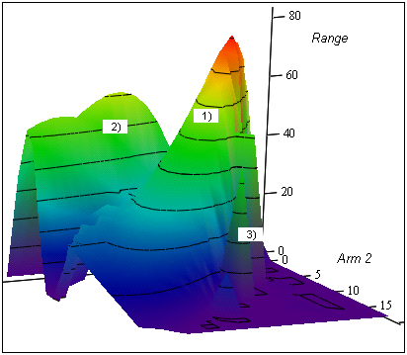
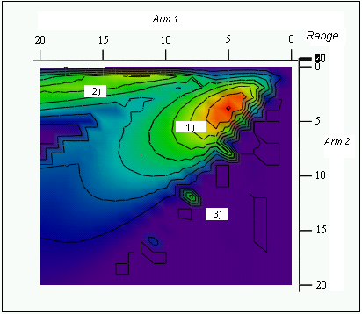 Several features are common to all of the arm-optimization graphs; these include: 1) a main peak in the area where the second arm is slightly shorter than the first, 2) a ridge alongside the Arm 1 axis, and 3) a chaotic ridge or line of cones within a region between the main peak and Arm 2 axis. The main peak corresponds to traditional trebuchet motion; the medieval trebuchets would undoubtedly fall in this region. The ridge along the main beam axis is a configuration with a very long main arm and very short second arm. This is approaching a simple single-armed counterweight catapult. The peak in this ridge corresponds to “good timing” with the second arm, in which the second arm is extended at the appropriate moment for release of the projectile. The valley between the main peak and secondary ridge results from a deceleration in the second arm just prior to release. The cone/ridge, 3), results from a chaotic, atypical trebuchet motion. It occurs in the region where the second arm is longer than the first. If this were attempted, the trebuchet would probably destroy itself before it could launch!
The next graph is an optimization of initial angles for the arms. The arm lengths were specified to be near the maximum of the previous graph at l₁ = 5 and l₂ = 4. The other parameters were set as specified above. The x-axis represents the initial angle of the main trebuchet arm, θ(0). The y-axis represents the initial angle of the second arm, φ(0).
Range is on the z-axis. The graph shows the entire space of possible initial angles – both 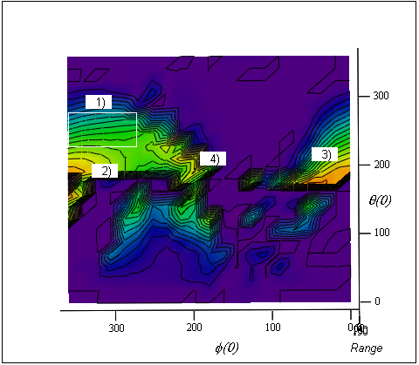 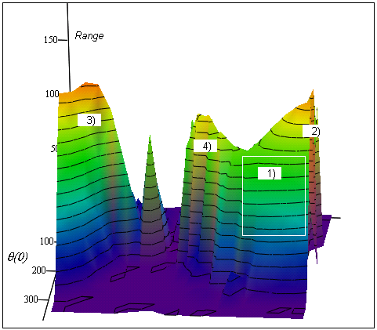
the x- and y-axis range from 0 to 360 degrees (by increments of 5 degrees). As a result, the graph loops around - if you run off of one side of it you start back on the opposite side. The initial-angle space is significantly more volatile than the arm-length space. Regions of the graph exist where a slight change in angle brings the range from near maximum to zero. The area in the box, region 1), is the region that traditional trebuchet throws inhabit. As you can see, this is not at a maximum of the space. The reason for this is practicality. The main peaks all lie near the θ =180 line. This is a very difficult configuration to set up, as it requires that the counterweight mass be almost straight up in the air. It is not surprising to have the maxima along the 180-line, because that line affords the greatest initial potential energy. This additional potential energy can then be converted into kinetic energy for the projectile. Notice also, that the highest maxima lie above the 180-line. This is easily explained because almost any configuration with 0 < θ < 180 actually throws in the opposite direction.
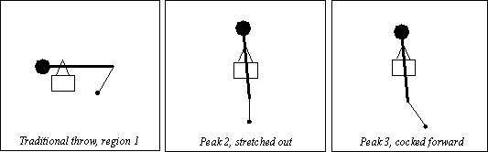
There is one main peak, designated by 2) and 3). The peak is divided over the edge of the graph; however, since θ =360 is equivalent to θ =0 this is actually a single peak. Traditional trebuchet throws are on the edge of this peak – in a more feasible region. The main peak is actually a double peak with maxima at 2) and 3). The maximum at 2) represents a completely stretched out trebuchet with the counterweight almost straight up in the air and the projectile hanging straight down. Trebuchet throws beginning with this configuration actually pass through the standard configuration (θ = -90, φ=slightly negative). Thus, a launch near 2) is equivalent to beginning a traditional trebuchet throw with a significant initial velocity. The maximum at 3) is actually a little higher than the one at 2). A trebuchet configured at 3) begins with the second arm cocked slightly forward. This seems like it would be detrimental to the velocity and range; however, the throw is slow enough that it allows for half of a pendulum-like cycle of the second arm. This cycle pumps kinetic energy into the projectile by creating a linear horizontal resonance, after which an upward non-linear resonance adds to the acceleration. This throw also passes through the traditional configuration during launch, with even greater velocity than a launch from region 2).
The actual global maximum detected by the optimization program for this space occurred at θ = 195, φ = 180. This maximum, near 4), is not visible on the graph because it is only a single point. If we zoom in the optimization program, and decrease the increment from 5 degrees to 0.5 degrees, then a narrow ridge emerges around this maximum.
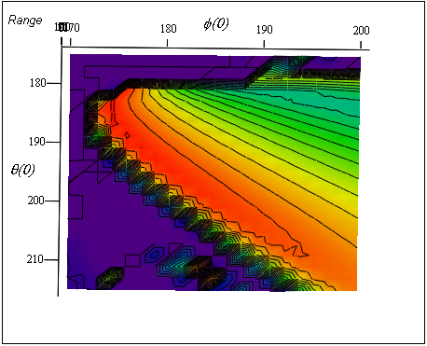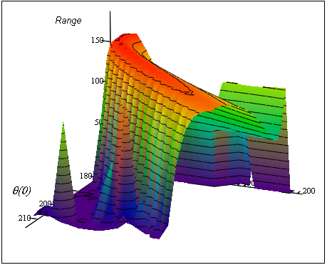
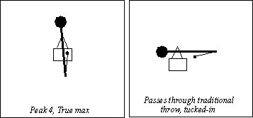
This ridge almost completely escapes the grid of the previous graph. Due its narrowness, this configuration would be difficult to achieve experimentally – a slight variation of initial conditions, friction coefficients, etc., could drastically decrease performance. The maximum itself is perilously “close to the edge.” The ridge corresponds to trebuchet throws with the counterweight almost all of the way up, and with the second arm slightly above a tucked-in position (so that it is actually above the main arm).

This is also near the maximum potential energy configuration of the trebuchet, as both the counterweight and projectile are almost as high as they can be. The projectile is nearly stationary during the first part of the throw. Like 2) and 3), this type of throw passes through the traditional trebuchet configuration; however, the second arm is much further tucked-in for 4), with θ ≈ -80, than it is for 2) or 3), with θ ≈ -10 to -20.
After examining the optimization space two dimensions at a time, it is useful to try optimization routines that optimize in all of the configuration dimensions at once. Previously, I used a nested for loop to test configurations. Theoretically, one could extend this method for any number of dimensions (and it would be a very thorough search). However, it is not practical given the number of calculations that would be required for such a routine. The required number of calculations increases as a power law for every additional for loop. This job requires a method that tests far fewer locations in the optimization space, yet remains capable of finding local maxima. I have chosen the downhill (or uphill in my case) simplex method for this purpose.
A simplex is a “geometrical figure consisting, in N dimensions, of N + 1 vertices and all their interconnecting line segments, polygonal faces, etc.” A two-dimensional simplex is a triangle. The simplex begins at an initial guess for the maximum – actually N + 1 initial guesses. There are four possible operations that the program can perform on the simplex: reflection, reflection and expansion, contraction, and multiple contraction. Reflection consists of reflecting the vertex with the lowest value through the face of the simplex opposite it. Depending on the value of the reflected point, the program can then expand the vertex out farther (if the reflection gave a better value) or contract the vertex in (if the value was worse). Another option, as the simplex nears a peak, is multiple contraction. This consists of bringing in all of the vertices closer to the maximum point. The routine eventually converges when the simplex reaches a peak and contracts down until all of the vertices are within a certain error value of each other.
The routine proved to find maxima very quickly – usually requiring 500 or fewer function evaluations. However, the trebuchet optimization space is so chaotic that which maximum is found depends greatly on the initial position of the simplex. Changing one of the vertices by a small amount typically changes the outcome of the routine. Every time that I ran the routine including a mass ratio dimension, it ended up running all the way up to the maximum allowed mass. As a result, most of the simplex optimization that I did involved only arm ratios and initial angles (to economize the number of calculations). When run in these four dimensions the program tended to converge in the initial-angle regions mentioned above. However, the results vary enough that little can be learned from the routine. The trebuchet optimization space is just too rocky for such a simple optimization routine. The routine was very successful at finding local maxima, but convergence varies too much for the program to suggest a global maximum. Further multi-dimensional optimization would require very sophisticated techniques designed specifically for searching volatile surfaces.
Two main principles fall out of the optimization graphs above. First, the trebuchet prefers high potential energy configurations. This is no surprise – in general, the higher the initial position of the counterweight and of the projectile, the better. Secondly, the highest peaks coincide with configurations that pass through the traditional trebuchet configuration, having already gained considerable angular velocity. Also, the further tucked-in the second arm is when it reaches the standard position, the higher the possible range.
These optimal configurations suggest that the “ultimate human throw” might be something like a backhand Frisbee throw preceded by a spin of the entire body (similar to a backwards discus throw). In this type of throw, the arm begins in a curled-up position. The person then spins his entire body around, the arm uncurls, and the projectile is released. The practicality of such a throw diminishes when one considers the disorientation created by spinning around. However, this does mimic the ultimate trebuchet throw. The initial spin increases the angular velocity of the system. Then, the arm begins – given this initial angular velocity – to unfold, much like the trebuchet unfolds from the standard position with its initial angular velocity. Another important feature of a trebuchet-like throw (as discovered by our semi-analytic models) is that the acceleration occurs early on and is due to the rotation of the entire system. This means that the human thrower does not need to tense arm muscles (the trebuchet has none) and strain at the last minute of a throw (as often seems natural). Instead, acceleration should come from the large muscle groups that are rotating the body – the arm could be almost completely relaxed. The rotation would provide ample acceleration without any potentially damaging arm straining. As in swinging a tennis racket or pick, the acceleration should occur very early in the process by force along the axis of the handle, as opposed to a last minute “hack.” “Hacking” is likely to damage arm muscles and joints, and without it one can focus on small last minute corrections that direct the stroke. Thus, optimized trebuchet data gives us some insight into how to execute more effective and less damaging motions in throwing and hitting.

V. N-armed Trebuchets
Another interesting problem is that of the n-armed trebuchet. Adding arms to the trebuchet could greatly increase performance. Three- and four-armed models would be better than two-armed models for describing certain human motions such as a forehand Frisbee throw. The n-armed trebuchet also has a relativistic analog in astrophysics: super-elastic bounce. It is conceivable that a trebuchet with enough arms could reach supersonic projectile speeds. Accelerating an object to such a speed using only a counterweight device would be quite an accomplishment of physics and engineering. If the initial conditions were set correctly, a wave that would increase in intensity at every segment could be sent along the arms – much like cracking a whip or snapping a towel. In fact, such motion might be modeled as a whip – a wave traveling through a string with ever decreasing mass density.
It is possible to derive a general form for the equations of motion of an n-armed trebuchet using symmetries in the DMC. I first noticed these symmetries while using Maple to derive DMCs for trebuchets with extra degrees of freedom, such as three- and four-armed trebuchets. The derivation can, however, be done analytically.
First notice that the coordinates expressing the positions of M and m can be put in a general form for any number of trebuchet arms. I take A₁…A_{n} as the variables that represent the angles of the n arms. For example, θ becomes A₁ and φ becomes A₂.
Coordinates of M: Coordinates of m:
$\begin{aligned}X=R\text{sin}A_{1}, \\ Y=−R\text{cos}A_{1},\end{aligned}$ $\begin{aligned}x=\sum_{i=1}^{n}{(−1)^{i}l_{i}\text{sin}A_{i}} \\ y=\sum_{i=1}^{n}{(−1)^{(i+1)}l_{i}\text{cos}A_{i}}\end{aligned}$ (27)

These coordinates hold for a trebuchet with arm angles defined in the following form.
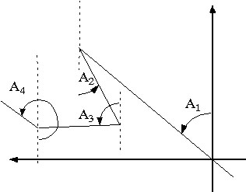

A positive angle is always counterclockwise, and the angles alternate being defined with respect to the positive and negative y-axis. It is then straightforward to derive the kinetic energy (T).
$\begin{aligned}\overset{˙}{X}=R{\overset{˙}{A}}_{1}\text{cos}A_{1}\text{ \{}\overset{˙}{x}=\sum_{i=1}^{n}{(−1)^{i}l_{i}{\overset{˙}{A}}_{i}\text{cos}A_{i}}\end{aligned}\overset{˙}{Y}=R{\overset{˙}{A}}_{1}\text{sin}A_{1}\text{ \{}\overset{˙}{y}=\sum_{i=1}^{n}{(−1)^{i}l_{i}{\overset{˙}{A}}_{i}\text{sin}A_{i}}T=\frac{1}{2}M({\overset{˙}{X}}^{2}+{\overset{˙}{Y}}^{2})+\frac{1}{2}m({\overset{˙}{x}}^{2}+{\overset{˙}{y}}^{2})T=\frac{1}{2}{\text{MR}}^{2}{\overset{˙}{A}}_{1^{2}}+\frac{1}{2}m\left[{\left(\sum_{i=1}^{n}{(−1)^{i}l_{i}{\overset{˙}{A}}_{i}\text{cos}A_{i}}\right)}^{2}+{\left(\sum_{i=1}^{n}{(−1)^{i}l_{i}{\overset{˙}{A}}_{i}\text{sin}A_{i}}\right)}^{2}\right]$ (28)
The summation terms are beginning to get nasty so we will take one individually and examine it.
${\overset{˙}{x}}^{2}={\left(−l_{1}{\overset{˙}{A}}_{1}\text{cos}A_{1}+l_{2}{\overset{˙}{A}}_{2}\text{cos}A_{2}+\text{.}\text{.}\text{.}+(−1)^{n}l_{n}{\overset{˙}{A}}_{n}\text{cos}A_{n}\right)}^{2}$ (29)
If we examine this term by term we see that a pattern emerges.

$\begin{aligned}{\overset{˙}{x}}^{2}=\left(l_{1^{2}}{\overset{˙}{A}}_{1^{2}}{\text{cos}}^{2}A_{1}−l_{1}l_{2}{\overset{˙}{A}}_{1}{\overset{˙}{A}}_{2}\text{cos}A_{1}\text{cos}A_{2}+\text{.}\text{.}\text{.}+(−1)^{(n+1)}l_{1}l_{n}{\overset{˙}{A}}_{1}{\overset{˙}{A}}_{n}\text{cos}A_{1}\text{cos}A_{n}\right) \\ + \\ \end{aligned}\begin{aligned}\left(l_{2^{2}}{\overset{˙}{A}}_{2^{2}}{\text{cos}}^{2}A_{2}−l_{2}l_{1}{\overset{˙}{A}}_{2}{\overset{˙}{A}}_{1}\text{cos}A_{2}\text{cos}A_{1}+l_{2}l_{3}{\overset{˙}{A}}_{2}{\overset{˙}{A}}_{3}\text{cos}A_{2}\text{cos}A_{3}+\text{.}\text{.}\text{.} | \right) \\ \end{aligned}$ (30)
Notice that each term in the x expression can be matched with a term in the y expression. Using three trigonometric identities, the sum of the expressions can be simplified.
From:
${\text{sin}}^{2}A+{\text{cos}}^{2}A=1$, $\text{cos}(A−B)=\text{sin}A\text{sin}B$, and $\text{cos}(A−B)=\text{cos}(B−A)$
it follows that:
${\overset{˙}{x}}^{2}+{\overset{˙}{y}}^{2}=\sum_{i=1}^{n}{l_{i^{2}}{\overset{˙}{A}}_{i^{2}}+\sum_{i=1}^{n}{\sum_{j=1}^{n}{(−1)^{(i+j)}l_{i}l_{j}{\overset{˙}{A}}_{i}{\overset{˙}{A}}_{j}\text{cos}(A_{i}−A_{j})}}}$ (31)
Therefore the kinetic energy of an n-armed trebuchet is: $T=\frac{1}{2}\left[({\text{MR}}^{2}+{\text{ml}}_{1^{2}}){\overset{˙}{A}}_{1^{2}}+\sum_{i=2}^{n}{{\text{ml}}_{i^{2}}{\overset{˙}{A}}_{i^{2}}+\sum_{i=1}^{n}{\sum_{j=1}^{n}{(−1)^{(i+j)}{\text{ml}}_{i}l_{j}{\overset{˙}{A}}_{i}{\overset{˙}{A}}_{j}\text{cos}(A_{i}−A_{j})}}}\right]$.
(32)
This can be expressed as a DMC matrix form.
$$T=\frac{1}{2}\left({\overset{˙}{A}}_{1},{\overset{˙}{A}}_{2},\text{.}\text{.}\text{.},{\overset{˙}{A}}_{n}\right)\left(\begin{matrix}{\text{MR}}^{2}+{\text{ml}}_{1^{2}} & −{\text{ml}}_{1}l_{2}\text{cos}(A_{1}−A_{2}) & \text{.}\text{.}\text{.} & \text{.}\text{.}\text{.} \\ −{\text{ml}}_{1}l_{2}\text{cos}(A_{1}−A_{2}) & {\text{ml}}_{2^{2}} & \text{.}\text{.}\text{.} & \text{.}\text{.}\text{.} \\ \text{.}\text{.}\text{.} & \text{.}\text{.}\text{.} & \text{.}\text{.}\text{.} & \text{.}\text{.}\text{.} \\ (−1)^{(n+1)}{\text{ml}}_{1}l_{n}\text{cos}(A_{1}−A_{n}) & −{\text{ml}}_{2}l_{n}\text{cos}(A_{2}−A_{n}) & \text{.}\text{.}\text{.} & {\text{ml}}_{n^{2}}\end{matrix}\right)\left(\begin{matrix}{\overset{˙}{A}}_{1} \\ {\overset{˙}{A}}_{2} \\ \text{.}\text{.}\text{.} \\ {\overset{˙}{A}}_{n}\end{matrix}\right)$$
(33)

The matrix is symmetric about the diagonal, and the coefficients obey the following rules:
for diagonal coefficients:
$γ_{i,i}=\left\{\begin{matrix}({\text{MR}}^{2}+{\text{ml}}_{1^{2}})\text{ , for i}=1 \\ {\text{ml}}_{i^{2}},\text{ for i }≠\text{ 1}\end{matrix}\right.$ (34)
for off-diagonal coefficients:
$γ_{i,j}=(−1)^{(i+j)}{\text{ml}}_{i}l_{j}\text{cos}(A_{i}−A_{j})$ (35)
Now we can use this general form of the DMC matrix to derive equations of motion. The next step is to express the potential energy of the system in terms of our new generalized coordinates.
$V=\text{MgY}+\text{mgy}=−\text{MgR}\text{cos}A_{1}+\sum_{i=1}^{n}{(−1)^{(i+1)}{\text{mgl}}_{i}\text{cos}A_{i}}$ (36)
The Lagrangian for the system is:
$L=T−V=\frac{1}{2}\left(\begin{matrix}{\overset{˙}{A}}_{1} & \text{.}\text{.}\text{.} & {\overset{˙}{A}}_{n}\end{matrix}\right)\left(\begin{matrix}γ_{1,1} & \text{.}\text{.}\text{.} & γ_{n,1} \\ \text{.}\text{.}\text{.} & \text{.}\text{.}\text{.} & \text{.}\text{.}\text{.} \\ γ_{1,n} & \text{.}\text{.}\text{.} & γ_{n,n}\end{matrix}\right)\left(\begin{matrix}{\overset{˙}{A}}_{1} \\ \text{.}\text{.}\text{.} \\ {\overset{˙}{A}}_{n}\end{matrix}\right)−\text{MgR}\text{cos}A_{1}+\sum_{i=1}^{n}{(−1)^{(i+1)}{\text{mgl}}_{i}\text{cos}A_{i}}$
(37)
We can now use Lagrange’s equations to solve for the motion. Recall that the conjugate momenta – the left side of Lagrange’s equations – can be expressed in the form $p_{μ}=\sum{γ_{μ,ν}\overset{˙}{ν}}\text{.}$ We can use this expression in combination with the DMC to obtain the respective conjugate momenta. Since the regularity within the DMC matrix breaks down when comparing diagonal and off-diagonal components, the conjugate momenta can be expressed in terms of their diagonal and off-diagonal components.

$\begin{aligned}p_{i}=\sum_{j=1}^{n}{(p_{i,j}^{\text{on}}+p_{i,j}^{\text{off}})} \\ p_{i,j}^{\text{on}}=\left\{\begin{matrix}({\text{MR}}^{2}+{\text{ml}}_{1^{2}}){\overset{˙}{A}}_{j},\text{ for }i=1\text{ and }i=j \\ {\text{ml}}_{i^{2}}{\overset{˙}{A}}_{j}\text{, for }i≠1\text{ and }i=j \\ 0,\text{ for }i≠j\end{matrix}\right. \\ p_{i,j}^{\text{off}}=(−1)^{(i+j)}{\text{ml}}_{i}l_{j}{\overset{˙}{A}}_{j}\text{cos}(A_{i}−A_{j})δ_{\text{ij}}\end{aligned}$ (38)
The next step is to take the total time derivative of the conjugate momenta.
$$\frac{d}{\text{dt}}(p_{i})=\begin{aligned}\left[\sum_{j=1}^{n}{\left((−1)^{(i+j+1)}{\text{ml}}_{i}l_{j}({\overset{˙}{A}}_{i}−{\overset{˙}{A}}_{j}){\overset{˙}{A}}_{j}\text{sin}(A_{i}−A_{j})+(−1)^{(i+j)}{\text{ml}}_{i}l_{j}{\overset{¨}{A}}_{j}\text{cos}(A_{i}−A_{j})\right)δ_{\text{ij}}} | \right] \\ \end{aligned}$$
(39)
This is the left-hand side of the Lagrange equations of motion. The right-hand side is $\frac{∂L}{∂A_{i}}=\frac{∂T}{∂A_{i}}−\frac{∂V}{∂A_{i}}\text{.}$ I will derive each one of the pieces individually. For the kinetic energy term the diagonal coefficients vanish because they do not contain any of the generalized coordinates A₁…A_{n}. Also, the ½ outside of the DMC cancels since there are two of each off-diagonal term. This leaves us with:
$\frac{∂T}{∂A_{i}}=\frac{∂}{∂A_{i}}\left[\sum_{j=1}^{n}{(−1)^{(i+j)}{\text{ml}}_{i}l_{j}{\overset{˙}{A}}_{i}{\overset{˙}{A}}_{j}\text{cos}(A_{i}−A_{j})δ_{\text{ij}}}\right]$. (40)
Differentiating gives us:
$\frac{∂T}{∂A_{i}}=\sum_{j=1}^{n}{(−1)^{(i+j+1)}{\text{ml}}_{i}}l_{j}{\overset{˙}{A}}_{i}{\overset{˙}{A}}_{j}\text{sin}(A_{i}−A_{j})δ_{\text{ij}}$. (41)
This term cancels out one of the terms on the left-hand side, leaving us with:
$\frac{d}{\text{dt}}(p_{i})−\frac{∂T}{∂A_{i}}=\begin{aligned}\left[\sum_{j=1}^{n}{(−1)^{(i+j)}{\text{ml}}_{i}l_{j}\left({\overset{˙}{A}}_{j^{2}}\text{sin}(A_{i}−A_{j})+{\overset{¨}{A}}_{j}\text{cos}(A_{i}−A_{j})\right)δ_{\text{ij}}} | \right] \\ \end{aligned}$ (42)
The remaining force term on the right is:
$−\frac{∂V}{∂A_{i}}=\left\{\begin{matrix}−\text{MgR}\text{sin}A_{1}+{\text{mgl}}_{1}\text{sin}A_{1},\text{ for }i=1 \\ (−1)^{(i+1)}{\text{mgl}}_{i}\text{sin}A_{i},\text{ for }i≠1\end{matrix}\right.$ (43)
If we set the right-hand side equal to the left-hand side we get the Lagrange equations of motion.$\begin{aligned}\text{For }i=1: \\ \text{ -M}\text{gR}\text{sin}A_{1}+{\text{mgl}}_{1}\text{sin}A_{1}=\begin{aligned}\left[\sum_{j=1}^{n}{(−1)^{(j+1)}{\text{ml}}_{1}l_{j}\left({\overset{˙}{A}}_{j^{2}}\text{sin}(A_{1}−A_{j})+{\overset{¨}{A}}_{1}\text{cos}(A_{1}−A_{j})\right)δ_{1j}} | \right] \\ \end{aligned} \\ \end{aligned}$
(44)
As with the equations of motion for the standard trebuchet, these equations can be expressed in matrix form.
$\begin{aligned}\left(\begin{matrix}({\text{ml}}_{1}−\text{MR})g\text{sin}A_{1} \\ −{\text{mgl}}_{2}\text{sin}A_{2} \\ \text{.}\text{.}\text{.} \\ (−1)^{(n+1)}{\text{mgl}}_{n}\text{sin}A_{n}\end{matrix}\right)= \\ \left(\begin{matrix}{\text{MR}}^{2}+{\text{ml}}_{1^{2}} & \text{.}\text{.}\text{.} & \text{.}\text{.}\text{.} & \text{.}\text{.}\text{.} \\ −{\text{ml}}_{1}l_{2}\text{cos}(A_{1}−A_{2}) & {\text{ml}}_{2^{2}} & \text{.}\text{.}\text{.} & \text{.}\text{.}\text{.} \\ \text{.}\text{.}\text{.} & \text{.}\text{.}\text{.} & \text{.}\text{.}\text{.} & \text{.}\text{.}\text{.} \\ \text{.}\text{.}\text{.} & \text{.}\text{.}\text{.} & \text{.}\text{.}\text{.} & {\text{ml}}_{n^{2}}\end{matrix}\right)\left(\begin{matrix}{\overset{¨}{A}}_{1} \\ {\overset{¨}{A}}_{2} \\ \text{.}\text{.}\text{.} \\ {\overset{¨}{A}}_{n}\end{matrix}\right)+\left(\begin{matrix}\sum_{j=1}^{n}{(−1)^{(j+1)}{\text{ml}}_{1}l_{j}{\overset{˙}{A}}_{j^{2}}\text{sin}(A_{1}−A_{j})δ_{1j}} \\ \sum_{j=1}^{n}{(−1)^{(j+2)}{\text{ml}}_{2}l_{j}{\overset{˙}{A}}_{j^{2}}\text{sin}(A_{2}−A_{j})δ_{2j}} \\ \text{.}\text{.}\text{.} \\ \sum_{j=1}^{n}{(−1)^{(j+n)}{\text{ml}}_{n}l_{j}{\overset{˙}{A}}_{j^{2}}\text{sin}(A_{n}−A_{j})δ_{\text{nj}}}\end{matrix}\right)\end{aligned}$(45)
It is then trivial to rearrange the equations so that they are explicit in the highest derivative (Riemannian form).
$\left(\begin{matrix}{\overset{¨}{A}}_{1} \\ {\overset{¨}{A}}_{2} \\ \text{.}\text{.}\text{.} \\ {\overset{¨}{A}}_{n}\end{matrix}\right)=\left(\begin{matrix}\text{Inverse} & \text{.}\text{.}\text{.} & \text{.}\text{.}\text{.} & \text{.}\text{.}\text{.} \\ \text{of} & \text{.}\text{.}\text{.} & \text{.}\text{.}\text{.} & \text{.}\text{.}\text{.} \\ \text{DMC} & \text{.}\text{.}\text{.} & \text{.}\text{.}\text{.} & \text{.}\text{.}\text{.} \\ \text{Matrix} & \text{.}\text{.}\text{.} & \text{.}\text{.}\text{.} & \text{.}\text{.}\text{.}\end{matrix}\right)\left[\left(\begin{matrix}({\text{ml}}_{1}−\text{MR})g\text{sin}A_{1} \\ −{\text{mgl}}_{2}\text{sin}A_{2} \\ \text{.}\text{.}\text{.} \\ (−1)^{(n+1)}{\text{mgl}}_{n}\text{sin}A_{n}\end{matrix}\right)−\left(\begin{matrix}\sum_{j=1}^{n}{(−1)^{(j+1)}{\text{ml}}_{1}l_{j}{\overset{˙}{A}}_{j^{2}}\text{sin}(A_{1}−A_{j})δ_{1j}} \\ \sum_{j=1}^{n}{(−1)^{(j+2)}{\text{ml}}_{2}l_{j}{\overset{˙}{A}}_{j^{2}}\text{sin}(A_{2}−A_{j})δ_{2j}} \\ \text{.}\text{.}\text{.} \\ \sum_{j=1}^{n}{(−1)^{(j+n)}{\text{ml}}_{n}l_{j}{\overset{˙}{A}}_{j^{2}}\text{sin}(A_{n}−A_{j})δ_{\text{nj}}}\end{matrix}\right)\right]$(46)
It would not be difficult to write a numerical simulator using this general form for the Riemann equations of motion for an n-armed trebuchet. The main addition to the calculation complexity would consist in the matrix inversion required. The matrix inversion would grow increasingly time-consuming as the number of arms increased. For large n, a whip approximation would likely be more effective. Once a simulator was constructed, an optimization routine could be used to find configurations that create the desired “whip” effect. Cracking a whip requires a forward and backward motion from the hand. It is likely that a trebuchet-whip would require forward and backward motion from the counterweight. This could be achieved if the time between start and release was greater than a half-cycle of the large arm. The main arm would swing backward to set the other arms in motion and then start back forward to send a wave down the arms. It is also likely that an optimal n-armed trebuchet would have gradually decreasing arm lengths – much as the optimal two-armed trebuchet has a shorter second arm. This would facilitate the amplification of angular velocity at each joint and is analogous to the dwindling of mass density near the end of the whip.
Optimization would require a sophisticated algorithm capable of dealing with very chaotic high-dimensional surfaces. For a two-armed trebuchet the optimization space is five-dimensional; however, for an n-armed trebuchet the space would be 2n+1-dimensional. This includes n dimensions for each additional arm length (excluding the counterweight lever length, which could be fixed), n dimensions for the initial angle of each arm, and one mass ratio dimension.

VI. Conclusion
Trebuchet motion is an integral part of our everyday work and play. The motion has been used not only to tear down castles, but also in the hewing of stones, hammering, and digging that were required to build those same castles. We now use it when throwing a ball, swinging a bat or racquet, and throwing a Frisbee. The motion has been little studied, partly due to its complexity. However, it is not unsolvable. Using a combination of analytic and numerical techniques, it is possible to create a computer model of the trebuchet. Furthermore, a single computer is capable of trying more possible trebuchet configurations in a few minutes than all of the medieval engineers combined could ever have tried. Using this advantage, today’s physicist can simulate thousands of trebuchets and discover which configurations are optimal. The results of such optimization suggest that the medieval trebuchets were near one of the optimization peaks. In fact, approaching closer to the optimal point would have required impractical configurations – the counterweight would have to be very high in the air. According to my optimization, the best configurations are those that: maximize potential energy, have a second arm slightly shorter than the first, and pass through the “traditional trebuchet” configuration during the throw (with the arm as tucked-in as possible). It would be difficult for a human to imitate this throw exactly, but it does provide some insight into the “optimal human throw.” This throw would help to maximize performance and minimize injury, and does not rely on tense arm muscles or (more damaging) torque around delicate joints.
It is conceivable that a supersonic throwing device could be constructed in the form of an n-armed trebuchet. Such a device would send a wave down the arms, intensified at each segment so that it creates a whip-like crack at the end. The device could be modeled using the general equations of motion that I derive above. Optimization routines would be needed to find configurations that would create such an amplified wave motion.

Paul E. Chevedden, Les Eigenbrod, Vernard Foley, and Werner Soedel, “The Trebuchet,” Scientific American 273, 1, (July 1995), p. 66-71. Evan Hadingham and Patrick Ward, “Ready, Aim, Fire!” Smithsonian (January 2000), p.80.
Andy W. Brown, “Analyzing the ACU Trebuchet,” Abilene Christian University (Unpublished). Donald B. Siano, “The Algorithmic Beauty of the Trebuchet,” http://www.members.home.com/diamona (Oct. 18, 2000).
Herbert Goldstein, Classical Mechanics, Addison-Wesley Press, Cambridge, 1951. L. D. Landau and E. M. Lifshitz, Mechanics, 3rd ed. Pergammon, New York, 1976. K. R. Symon, Mechanics, 3rd ed. Addison-Wesley, Reading, Massachusetts, 1971. Jerry B. Marion and Stephen T. Thornton, Classical Dynamics of Particles and Systems, 4th ed. Harcourt Brace, Orlando, 1995.
S. E. Wollsley, and M. M. Phillips, “Super-Nova 1987A!” Science 240, 750 (May 1988).
William Harter carries out a similar analysis in his unpublished paper, “Trebuchet versus Flinger: Millennial mechanics and bio-mechanics problems.”
This analogy is drawn in, “Trebuchet versus Flinger: Millennial mechanics and bio-mechanics problems.”
Vectors are expressed by bold type.
Morse and Feshbach, Methods of Theoretical Physics: Part I, McGraw-Hill, New York, 1953, p556-557.
William Harter, Classical Mechanics with a Bang. (unpublished)
William H. Press, Saul A. Teukolsky, William T. Vetterling, Brian P. Flannery, Numerical Recipes in C: Second Edition, Cambridge University Press, Cambridge, 1999, p. 710-712.
Ibid. p. 712.
Graphing was done in Math Cad.
For a discussion of this method see: Numerical Recipes in C, p. 408-412, and S.L.S Jacoby, J.S. Kowalik, and J.T. Pizzo, Iterative Methods for Nonlinear Optimization Problems, Prentice-Hall, Englewood Cliffs, NJ, 1972.
Numerical Recipes. p. 408.

